Exercise #7
on course “Cryptography …..”
topic: Shanks

[Prelegerea 12 ElGamal]


Task
[Prelegere 12 El Gamal]
Realize Shanks algorithm.
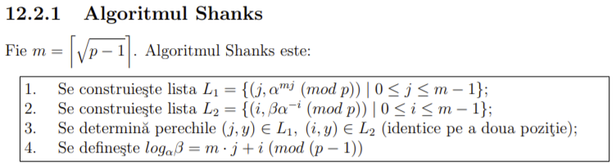

Let p = 193 and let’s determine log₅75 mod193 =14*6+2 mod(p-1)=
Hence:
α = 5 (PrimitiveRoot[193]),
β = 75 ( < 193, and > 0),
m = ┌ (192)^1/2 ┐= 14 (ceil(sqrt(192)),
α^{m} mod p = 5¹⁴ mod 193 = 56.

List L₁ of pairs (j, 56 ^{j} (mod 193)), 0 <= j <= 13:

(0, 1) (1, 56) (2, 48) (3, 179) (4, 181) (5, 100) (6, 3)
(7, 168) (8, 144) (9, 151) (10, 157) (11, 107) (12, 9) (13, 118)

List L₂ of pairs (i, 75 * (5^{i})⁻¹(mod 193), 0 <= i <= 13:

(0, 75) (1, 15) (2,3) (3, 155) (4, 31) (5, 122) (6, 63)
(7, 167) (8, 72) (9, 53) (10, 165) (11, 33) (12, 161) (13, 148)

(13, 118) belongs to L₁, (10, 118) belongs to L₂
Hence
log₅71 = 14 * 6 + 2mod192 = 84 + 2 = 86
Testing
5⁸⁶ mod193 = 75mod193 = 75

Code listing:

import java.util.Scanner;
public class Shanks {
private static final int LIMIT = 32000;
public static void main(String[] args) {
int a=0;
int b=0;
int p=0;
try {
System.out.println("Logarifmul discret");
System.out.println(" a ^ x === b (mod p)");
System.out.println("Exemplu: 31 ^ 5 === 3 (mod 29)");
System.out.println("Introduce a : ");
a = (new Scanner(System.in).nextInt());
System.out.println("Introduce b : ");
b = (new Scanner(System.in).nextInt());
System.out.println("Introduce p : ");
p = (new Scanner(System.in).nextInt());
} catch (Exception e) {
System.out.println("Introduse datele incorecte. Numai cifrele pot fi introduse.");
System.exit(1);
}
if (a < 1 || b < 1 || p < 1) {
System.out.println("Datele introduce sunt incorecte. Numai cifrele positive pot fi introduse.");
System.exit(1);
}
int raspuns = aInXModPEqB(a, p, b, LIMIT);
if (raspuns >= 0) {
System.out.println("Raspuns : " + raspuns + "\r\n");
System.out.println(" " + a + " ^ " + raspuns + " === " + b
+ " (mod " + p + ")");
} else {
System.out.println("Raspuns nu a fost gasit.");
}
}
/** a ^ x === b (mod p) */
public static int aInXModPEqB(int a, int p, int b, int limit) {
for (int i = 1; i < limit; i++) {
if (pow_mod(a, i, p) == b)
return i;
}
return -1;
}
/** a ^ k mod n */
public static long pow_mod(long a, long k, long n) {
long b = 1;
while (k > 0) {
if (k % 2 == 0) {
k /= 2;
a = (a * a) % n;
} else {
k--;
b = (b * a) % n;
}
}
return b;
}}

Results:

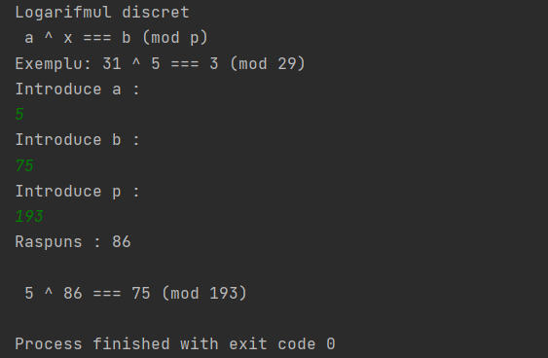

Conclusion:

Применив асимметричный алгоритм шифрования Shank, мне удалось вычислить дискретный логарифм. Результат ручного подсчета совпал с правильным ответом в ходе проверки решения. Результаты ручного вычисления совпали с результатами запрограммированного алгоритма, что подтверждает правильность ответа.
Bibliography:

Code: The Hidden Language of Computer Hardware and Software, Book by Charlez Petzold, Microsoft Press, October 23, 1999

Serious Cryptography: A Practical Introduction to Modern Encryption, Book by Jean-Philippe Aumasson, 2017

Cryptography, Book by Rubinstein-Salzedo Simon, 2018

Information Security, 2Ed: Principles And Practices, book by Mark Stamp, 2018

Introduction to Cryptography, Book by Sahadeo Padhye, Rajeev A.Sahu, Vishal Saraswat, 2018

